

**RESTAURANT WEBSITE**

**SKILL TRAINING REPORT**

*SUBMITTED BY*

**II – YEAR**

**CSE ‘A’**

**ANIMUTHU ABISHEK .P (95072212011)**

**ASHIK HABEEB (95072212017)**

**BALASUBRAMANIAN .N.M (95072212025)**

***In partial fulfillment for the award of the degree of***

BACHELOR OF ENGINEERING

***In***

COMPUTER SCIENCE & ENGINEERING

**FRANCIS XAVIER ENGINEERING COLLEGE**

**(Autonomous)**

**TIRUNELVELI – 627003**



**Abstract**

The 'Restaurant Website' project aims to create a visually appealing and user-friendly website for a fictitious restaurant. This project primarily involves using HTML (Hypertext Markup Language) to structure and design the web pages. The website will include features such as a homepage, menu page, reservation system, and contact information. Through the use of HTML, we intend to deliver a responsive and interactive web experience for users, providing essential information about the restaurant, its menu, and a seamless reservation process. This project highlights the importance of HTML in web development and serves as a foundation for creating an engaging online presence for a restaurant.

**Software Used**

Text editors like Visual Studio Code, Sublime Text, or Notepad++ to write and edit your HTML and CSS code. HTML is the core language for creating the structure and content of our website. It helps to define headings, paragraphs, links, images, and more. Cascading Style Sheets (CSS) are used to control the layout, design, and styling of your website. We can use a text editor or CSS pre-processors like SASS or LESS. Any modern web browser like Google Chrome, Mozilla Firefox, or Microsoft Edge will be essential for testing and previewing your website. Tools like Adobe Photoshop, GIMP, or Canva can help you create and edit images for your website, such as menu items or background images. In summary, visual studio code provides basic support for HTML programming out of the box. There is syntax highlighting, smart completions with IntelliSense, and customizable formatting.

**Project description**

**Project Title:** ***Restaurant Website***

**Project Description:**

Create a fully functional and aesthetically pleasing website for a restaurant to showcase its menu, attract customers, and provide essential information. The project will primarily utilize HTML and CSS to design and structure the website.

**Key Features:**

1. ***Homepage:*** Design an attractive homepage with the restaurant's name, logo, and a captivating image of the restaurant's interior or signature dish. Include a welcoming message and a brief introduction.

2. ***Product Page:*** Create a product page that lists the restaurant's offerings, like pizza, burgur, etc. Each menu item should include a name, description, and price.

3. ***Image Gallery:*** Develop an image gallery that displays high-quality images of the restaurant's dishes, interior. Implement a lightbox feature that allows users to view images in a larger format.

4. ***Contact Information:*** Provide a contact page with the restaurant's address, phone number, email address. Include a contact form that allows users to send feedback to satisfy the customer.

5. ***About Us:*** Create an "About Us" page that shares the restaurant's history, mission, and values. Include information about the chef and the restaurant's commitment to quality.

6. ***Services:*** Providing online food services such as Swiggy, Zomato where customer get their food on doorstep quickly with fresh hot.

7. ***Responsive Design:*** Ensure that the website is responsive and works well on various devices, including desktops, tablets, and mobile phones. Use CSS media queries to adapt the layout.

8. ***CSS Styling:*** Apply CSS to style the website, including fonts, colors, backgrounds, and layout. Ensure the design aligns with the restaurant's brand identity and creates an inviting atmosphere.

***\*Project Goals:\****

- To create a visually appealing and user-friendly restaurant website.

- To provide essential information to potential customers, including the menu, contact details.

- To showcase the restaurant's ambiance and menu items through images.

- To engage with customers through testimonials and an "About Us" section.

**Flowchart**

Restaurant Management

Website

User

Login

Ordering food and its quantity

Payment details

Order placed successfully

**Coding**

|  |  |
| --- | --- |
|  | **<!DOCTYPE html>** |
|  | **<html lang="en" >** |
|  | **<head>** |
|  | **<meta charset="UTF-8">** |
|  | **<title>CodePen - Facebook Login Page</title>** |
|  | **<link rel="stylesheet" href="****./style 1.css****">** |
|  |  |
|  | **</head>** |
|  | **<body class="background">** |
|  | **<!-- partial:index.partial.html -->** |
|  | **<div class="container flex">** |
|  | **<div class="facebook-page flex">** |
|  | **<div class="text">** |
|  | **<h1 >Welcome To</h1>** |
|  | **<p>"SHEJA FOODS." </p>** |
|  | **<H2>"People who love to eat are always the best people."</H2>** |
|  | **</div>** |
|  | **<form action="#">** |
|  | **<input type="email" placeholder="Email or phone number" required>** |
|  | **<input type="password" placeholder="Password" required>** |
|  | **<div class="link">** |
|  | **<button type="submit" class="login">Login</button>** |
|  | **<a href="****#****" class="forgot">Forgot password?</a>** |
|  | **</div>** |
|  | **<hr>** |
|  | **<div class="button">** |
|  | **<a href="****#****">Create new account</a>** |
|  | **</div>** |
|  | **</form>** |
|  | **</div>** |
|  | **</div>** |
|  | **<!-- partial -->** |
|  |  |
|  | **</body>** |
|  | **</html>** |
|  |  |

**Output: 1**

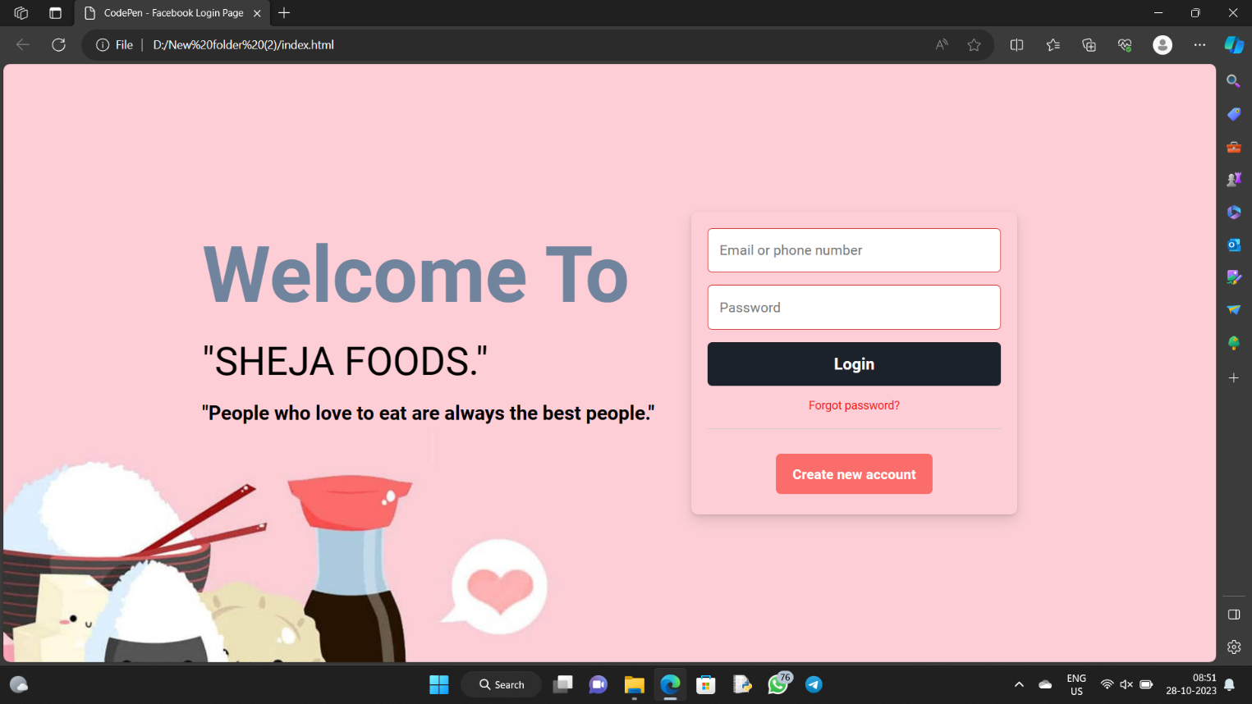

Output: 2

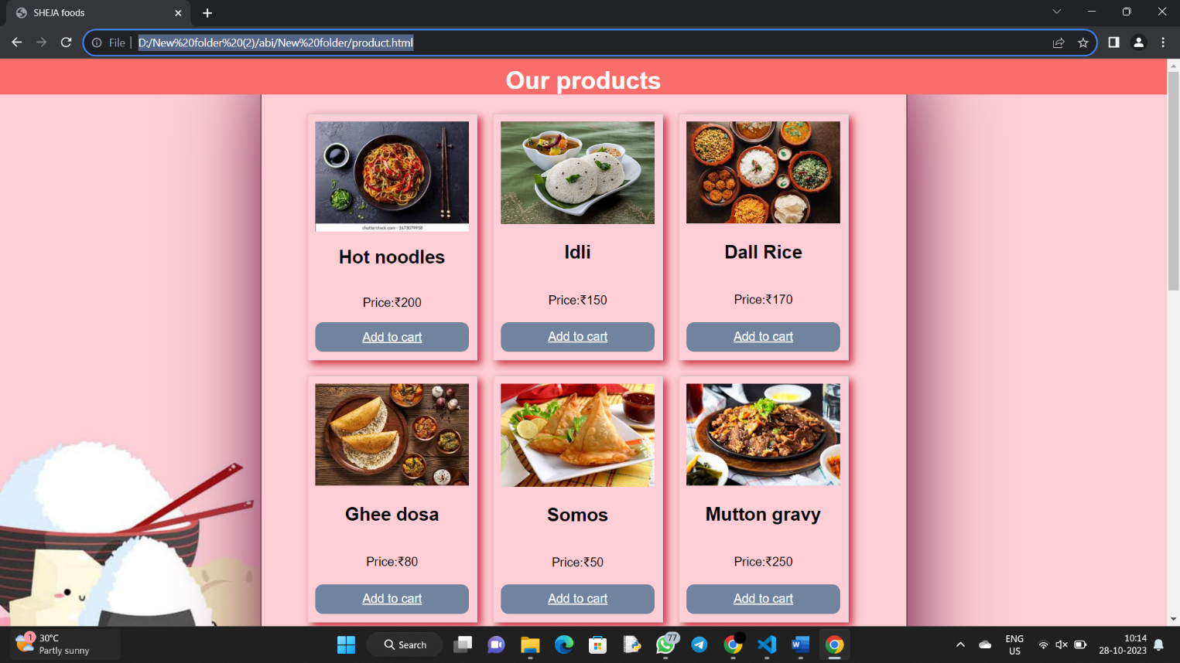

**Conclusion**

In conclusion, the development of the restaurant website using HTML and CSS has been a successful and rewarding project. We have created a visually appealing and user-friendly website that effectively showcases the restaurant's offerings and provides a seamless experience for visitors. Through the use of responsive design techniques, we have ensured that the website is accessible on various devices, enhancing its reach.

The key features and elements we implemented, such as the menu display, image galleries, contact information, and reservation form, have greatly enhanced the user experience. The use of CSS for styling has allowed us to maintain a consistent and appealing design throughout the website.

In terms of future improvements, we could consider integrating additional features like online ordering, customer reviews, and social media links to further engage with the audience and increase the restaurant's online presence.

Overall, this project has not only been an opportunity to apply HTML and CSS skills but also a valuable experience in web development and design. It has resulted in a functional and aesthetically pleasing restaurant website that effectively serves its purpose.